Artificial Neural Network

A Project Report Submitted
for

Information Technology
By

Saumya Joshi

Under the guidance of
Mr. Praveen Kumar Joshi



EVER GREEN SENIOR SECONDARY SCHOOL
(GOVERNED BY EDUCATIONAL WELFARE SOCIETY)
TULARAMPUR - 263139, DISTRICT-NAINITAL
UTTARAKHAND, INDIA

OCTOBER, 2021

CERTIFICATE

This is to certify that the project entitled “Artificial Neural Network” being submitted to Evergeen Senior Secondary School, Haldwani for the project work of INFORMATION TECHNOLOGY is a record of the work carried by SAUMYA JOSHI.

Date : 10/10/21

Supervisor
MR. PRAVEEN JOSHI
TGT Computer
Ever Green Sr. Sec. School, Haldwani
Forwarded By:
MR. M.S. PARWAL
Principal
Ever Green Sr. Sec. School, Haldwani

ACKNOWLEDGEMENTS
I would like to express my gratitude and respect to my supervisor MR. PRAVEEN JOSHI, for suggesting the topic for my project work and for his excellent guidance, valuable suggestions and endless support throughout for preparing the project and Mr. M.S. Parwal, Principal of School, and entire faculty who has imparted considerable knowledge to me.
Secondly, I express my deepest gratitude to my parents for their continuous encouragement, understanding ,support and finalizing this report .
At last I would like to thank Google and YouTube for providing a lots of information and knowledge for completing my project on ARTIFICIAL NEURAL NETWORKS.

(Saumya Joshi)

TABLE OF CONTENTS

Chapter | Topic | Page No.
 | CERTIFICATE | 2
 | ACKNOWLEDGEMENT | 3
 | ABSTRACT | 5
 | INTRODUCTION | 6
1. | WHAT ARE ANN | 6
2. | HOW DO ARTIFICIAL NEURAL NETWORKS WORK? | 7
3. | EXPERIENCE OF COGNITIVE NEUROSCIENTIST | 8
4. | HOW DO ANNs LEARN | 8
5. | WHAT ARE ANNs USED FOR | 8
5.1. | ANNs in Google | 9
5.2. | ANNs in YouTube | 9
5.3. | ANNs in Facebook | 9
6. | SUMMARY | 10
7. | FUTURE OF ANNs | 10

LIST OF FIGURES

S.No. | Name | Page No.
1. | Artificial Neural Network | 6
2. | Layers of ANNs | 7
3. | Uses of ANNs | 9

ABSTRACT
As humans are able to learn various new things and make their decisions themselves, as like Artificial Neural Network is a way to replicate the network of neurons as like human brain, so then the computer will also be able to learn new things and make their decisions by their own.

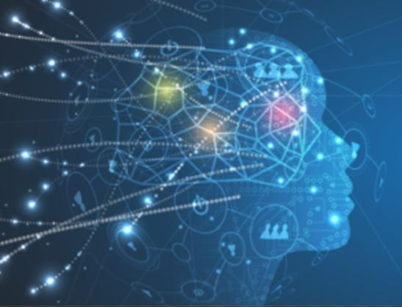
1.Artificial neural networks

Introduction
There are many things compute-s can do better than humans – Calculate square roots or retrieve a web page Instantaneously but our incredible brains are still a step ahead when it comes to common sense, inspiration and imagination. Inspired by the structure of the brain artificial neural networks are the answer to making computers more like and help like machines reason more like humans.
What are ANNs
Human brains interpret the context of real world situations in a way that computer cannot neural networks were first developed in the 1950s to address this issue an artificial neural network is an attempt to simulate the network of neurons that make up a human brain so that the computer will be able to learn things and make decisions in a human like manner A and ends are created by programming regular computer to behave as though they are interconnected brain cells.
How do artificial neural networks work?
Artificial neural network use different layers of mathematical processing to make sense of the information it’s fed. Typically, an artificial neural network has any fear from dozens to millions of artificial neurons-called units- arranged series of layers.The input layer receives various forms of information from the outside world. This is the data that the network aims to processes or learn about. From the input unit, the data goes through one or more hidden units. That returns unit job is to transform The input into something the output unit can use.
The majority of neural networks are fully connected from one layer to another . this connections are weighted, the higher the number the greater influence one unit has on another, similar to a human brain. As the data goes through each unit the network is learning more about the data .On the other side of the network is the output units, and this is where the network responds to the data that it was given and processed.
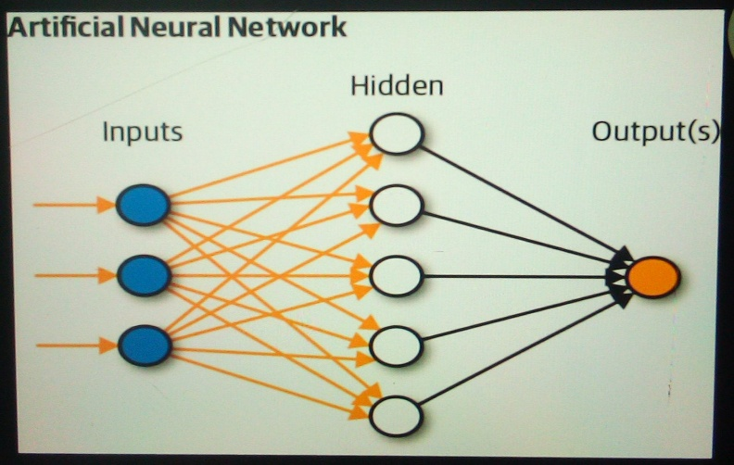
2. Layers of ANNs

Experience of cognitive neuroscientist
They have learned a tremendous amount about the human brain since computer scientists first attempt the original artificial neural network. One of the things they learn is that different parts of the brain are responsible for processing different aspects of information and these parts are arranged hierarchically. So, input comes into the brain and each level of neurons provide insight and then the information gets passed on the next step more senior level that previously the mechanism add that ANN are trying to replicate.
How do ANNs learn?
In order for a NNS to learn they need to have a tremendous amount of information thrown at them called a training set. When you are trying to teach an an and how to differentiate a cat from dog that training set word provide thousands of images tracked as dog so the network will bring to learn., Once it has been trained with the significant amount of data, it will try to classify future data based on what it thinks it’s or hearing depending upon the set of data, throughout the different units. During the training period , the machine's output is compared to humans- provided description of what should be observed. If they are same ,the machine is validated . If it’s incorrect ,it uses back propagation to adjust it’s learning- going back through the layers to tweak the mathematical equation. Known as deep learning , this is what makes a network intelligent.
What are ANNs used for ?
There are several ways artificial neural networks can be deployed including to classify information, predict outcomes and cluster data. As the network process and learn from data they can classify a given data set into a predefined class , it can be trained to predict outcomes that are expected from a given input.
ANNs in Google
Google uses a 30 layered neural network to power Google photos .
ANNs in YouTube
YouTube uses artificial neural networks to power it’s “ watch next” recommendations for YouTube videos .
ANNs in Facebook
Facebook uses ANNs for its deep face algorithm ,which can recognize specific faces with 97 % accuracy.
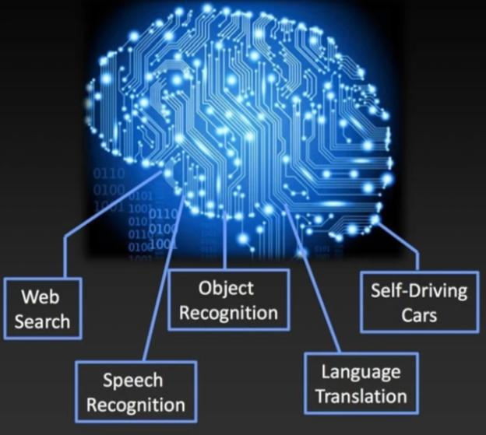
3. Uses of Artificial Neural Network
Summary
- Artificial neural networks is a machine learning approach that models human brain and consists of a number of Artificial neurons.
- Neuron is ANNs tend to have fewer connection than biological neurons.
- Each neuron in ANNs receives a number of inputs.
- A function called activation function is applied to these inputs which results in activation level of neurons and give output.

Future of Artificial Neural Network
With technological advancement , we can make CPUs and GPUs cheaper and faster enabling the production of bigger ,more efficient algorithms. We can also neural nets capable of processing more data and processing data faster so it may learn to recognize patterns with just 1000 examples instead of 10000.

